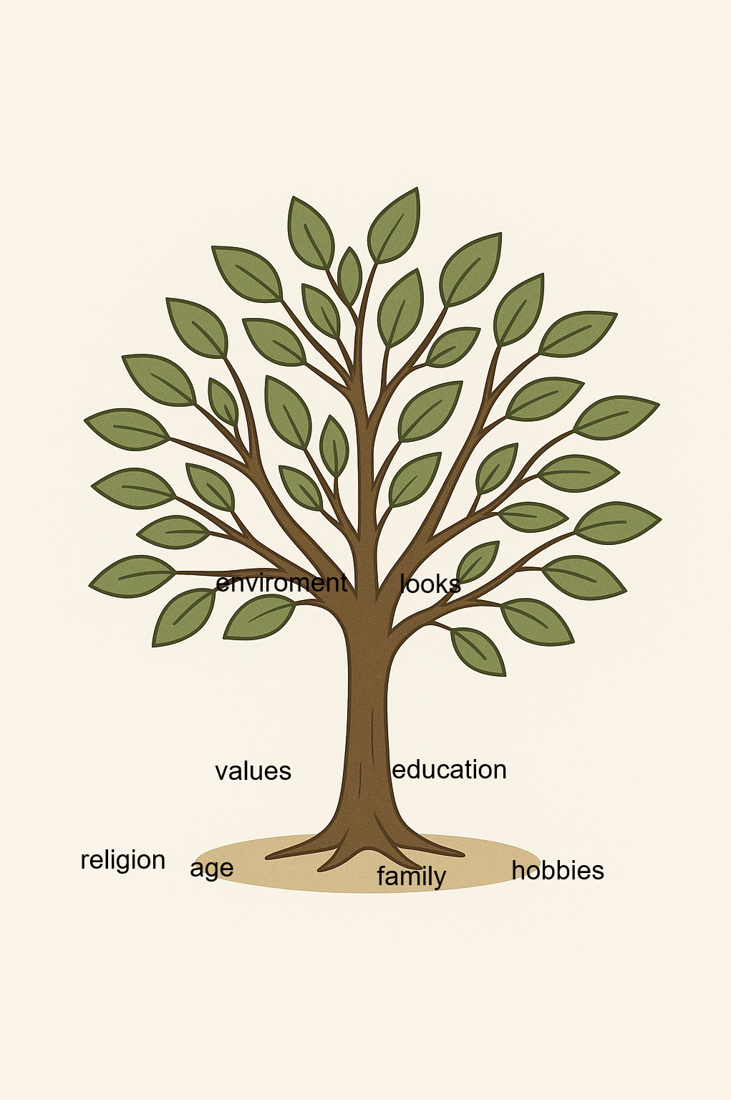
Religion – is down in the tree because it is the thing that defines me most.
Age – down in the tree because my age makes me being able to do lot of thing although it also make me being not able to do certain things.
Family – down in the tree because my family are the people who raised me and helped me shape my identity.
Hobbies – down in the tree because my hobbies are the things I do in my free time.
Values – in the middle of the tree because my values are how I live my life and I think that its not one of the strongest things in my personality.
Education – in the middle of the tree because my education is not something I choose in the part of life I'm in.
Looks – up in the tree because I don’t think that how other people see me should be what makes my identity.
Environment – up in the tree because other people shouldn’t be what defines my identity so it isn’t.

