Page 27:
Entry 2:
I chose the Trump and Zalensky's conflict earlier this year.
Trump and Zalensky are both in the middle age stage. The conflict was about Ukraine not saying "thanks" to the united states of America after all of the help the US gave Ukraine. I think that Trump could have overcome this conflict by not wanting to be admired by everyone. I can see that Trump is always looking for admiration because of how he acts in other conflicts.
Erickson's theory help me understand relationships around me by letting me understand what skills people need to get to develop. I think that the idea that a person failing a stage cant move forward to the next stage until he meet the challenge is totally wrong and I see that because if a person doesn’t meet the last challenge in life won't die is totally wrong. I also think that if a person haven’t succeeded in a stage he will be stuck in it is totally wrong. I thing that if someone haven’t succeeded in a stage he will move to the next stage but without the ability to handle it.
A person can correct failing a certain stage by going back (to his memories) and think about what he did wrong. I think that its true because you can't get back in time but you can think what you did wrong and get lessons from it and this is the only way to move forward. someone who is failing a stage need to remember not only the bad things but also the good things because we can take lessons from things we did right and not only things we did wrong.

Entry 1:
1.

My identity web:
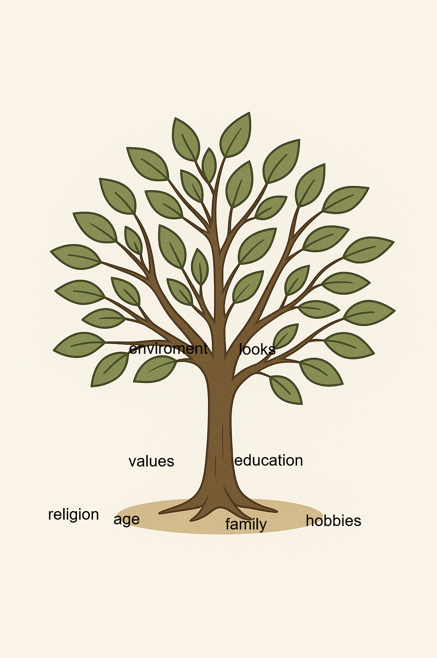

2.
My motto regarding conflict is "don’t worry be happy".
3.
My quote is "don’t worry be happy" from the song "don’t worry be happy" by Bobby McFerrin.
this quote reflects my belief on conflict because I am a person that believe that every conflict can be solved in a peaceful (non violent) way and in this way everyone can be happy.
4.
My conflict style is avoiding. A recent conflict in my life was yesterday when my mother forgot to tell my father about a new medicine I need to take in school. My father sayed to my educators that he doesn’t agree that I will take the medicine because he doesn’t know what is this medicine. I needed to call my father to ask him why he did it and I wanted to avoid a conflict with him even though my mather told me that she sent him what my doctor told us including the need to take this new medicine. In this situation I needed to get into a conflict with my father but my conflict style harmed the situation because I had to get in a conflict with him to tell him that he can't not letting me do what I need to do because he want to annoy my mather.

